**ABOUT THE DATASET :-**

* CONSISTS OF EIGHT ATTRIBUTES.
* NAMELY -> Age, Profession, Marital Status, Education, No of Dependents, Personal loan, Total salary, Price.
* Datatypes -> (Age, No of Dependents, Price, Total Salary) : integer & (Profession, Marital status, Education, Personal loan): object data type
* No empty values in between.
* Modules used: NumPy, pandas, matplotlib, seaborn
* Having 99 rows and 8 columns.

**NUMERICAL DISTRIBUTIONS :-**

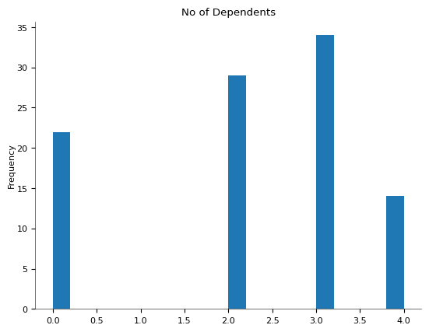

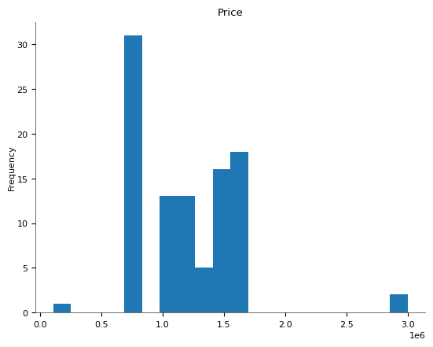 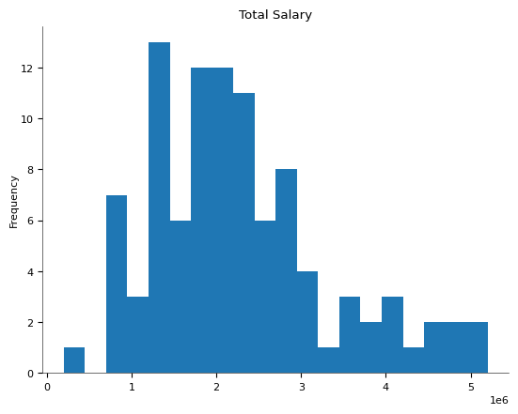

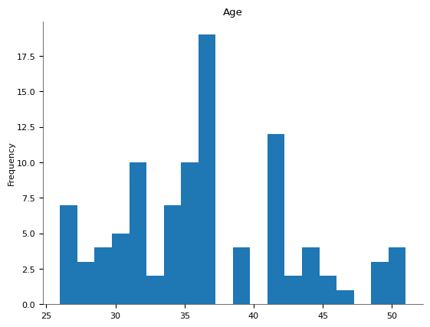

**CATEGORICAL DISTRIBUTIONS:-**

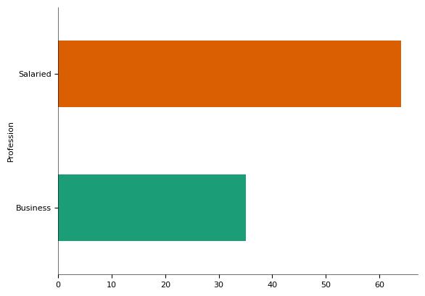 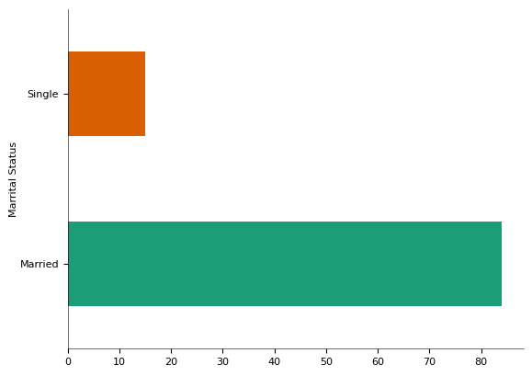 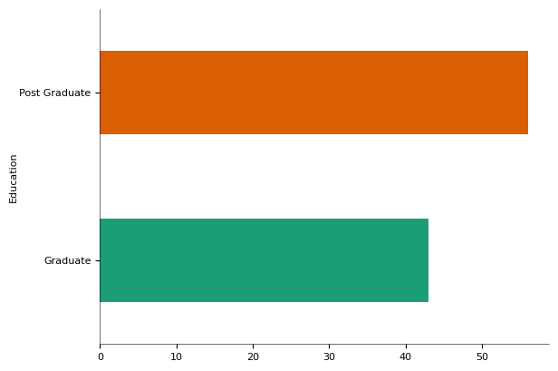

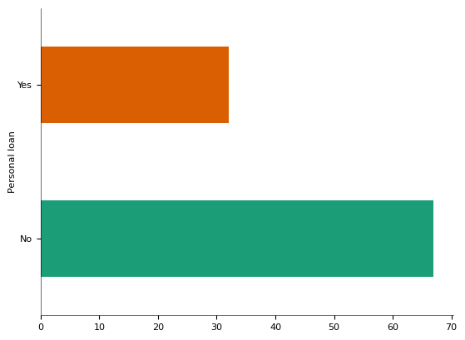

**CORRELATION BETWEEN NUMERICAL ATTRIBUTE:-**

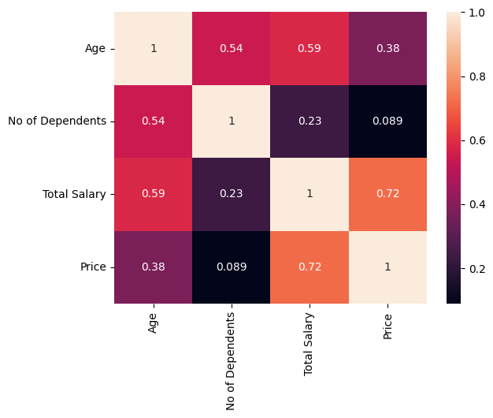

* Here,high correlation between Salary & Price.

[{"index":"count","Age":"99.0","No of Dependents":"99.0","Total Salary":"99.0","Price":"99.0"},{"index":"mean","Age":"36.313131313131315","No of Dependents":"2.1818181818181817","Total Salary":"2270707.0707070706","Price":"1194040.4040404041"},{"index":"std","Age":"6.246054206941395","No of Dependents":"1.3352645259872389","Total Salary":"1050777.4114525313","Price":"437695.54042274354"},{"index":"min","Age":"26.0","No of Dependents":"0.0","Total Salary":"200000.0","Price":"110000.0"},{"index":"25%","Age":"31.0","No of Dependents":"2.0","Total Salary":"1550000.0","Price":"800000.0"},{"index":"50%","Age":"36.0","No of Dependents":"2.0","Total Salary":"2100000.0","Price":"1200000.0"},{"index":"75%","Age":"41.0","No of Dependents":"3.0","Total Salary":"2700000.0","Price":"1500000.0"},{"index":"max","Age":"51.0","No of Dependents":"4.0","Total Salary":"5200000.0","Price":"3000000.0"}]

* There, are earning professionals like businessmen, and salaried., having other dependent members in their families (0-4).
* All of them are Educated(Graduate or Post-Grad), having age from 26 yrs to 51 yrs.
* Salaries ranging from 8 lpa to 51 lpa.

**SEGMENTATION:-**

* SCATTER ANALYSIS USING KPROTOTYPE.
* Changed the numerical features to float types.
* Performed analysis for Price and Salary earned.

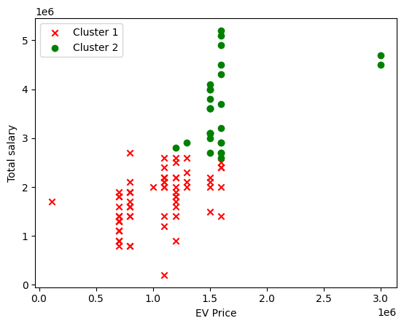

**RESULT:-**

EV Price around 1.5 lack are bought much.